**Python Code Challenges: Lists**

**Python Code Challenges involving Lists**

This article will help you review Python functions by providing some code challenges involving lists.

Some of these challenges are difficult! Take some time to think about them before starting to code.

You might not get the solution correct on your first try — look at your output, try to find where you’re going wrong, and iterate on your solution.

Finally, if you get stuck, use our solution code! If you “Check Answer” twice with an incorrect solution, you should see an option to get our solution code. However, truly investigate that solution — experiment and play with the solution code until you have a good grasp of how it is working. Good luck!

**Function Syntax**

As a refresher, function syntax looks like this:

def some_function(some_input1, some_input2):  
  # … do something with the inputs …  
  return output

For example, a function that returns the sum of the first and last elements of a given list might look like this:

def first_plus_last(lst):  
  return lst[0] + lst[-1]

And this would produce output like:

>>> first_plus_last([1, 2, 3, 4])  
5  
>>> first_plus_last([8, 2, 5, -8])  
0  
>>> first_plus_last([-10, 2, 3, -4])  
-14

**Challenges**

We’ve included 5 list challenges below. Try to answer all of them and polish up your problem-solving skills and your list expertise

**1. Append Size**

For the first code challenge, we are going to calculate the length of a list and then append the value to the end of the list. Here is what we need to do:

1. Define the function to accept one parameter for our list
2. Get the length of the list
3. Append the length of the list to the end of the list
4. Return the modified list

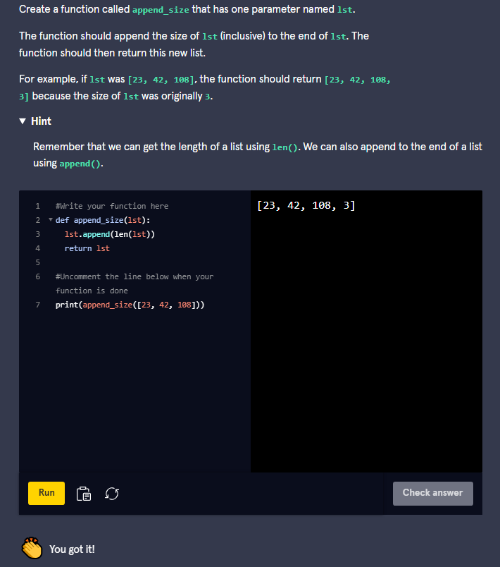

Here is this solution:

def append_size(lst):  
  lst.append(len(lst))  
  return lst

We can get the length and append it at the same time by nesting the function calls as shown in the solution. Afterward, we return the modified list.

### 2. Append Sum

Let’s create a function that calculates the sum of the last two elements of a list and appends it to the end. After doing so, it will repeat this process two more times and return the resulting list. You can choose to use a loop or manually use three lines. Here are the steps we need:

1. Define the function to accept one parameter for our list of numbers
2. Add the last and second to last elements from our list together
3. Append the calculated value to the end of our list.
4. Repeat steps 2 and 3 two more times
5. Return the modified list

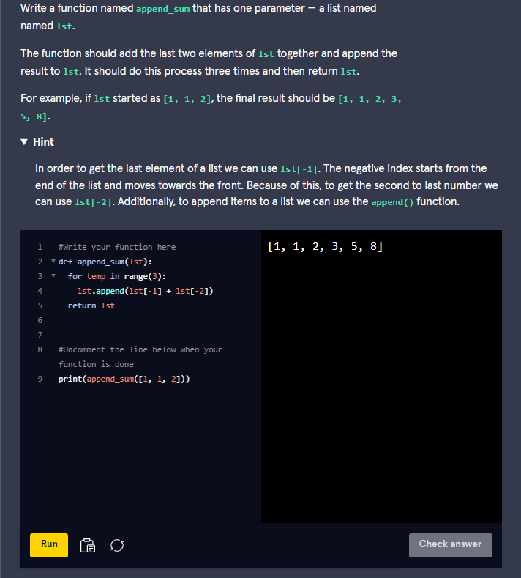

This is how we solved it:

def append_sum(lst):  
  lst.append(lst[-1] + lst[-2])  
  lst.append(lst[-1] + lst[-2])  
  lst.append(lst[-1] + lst[-2])  
  return lst

In our solution, we add the numbers and append the result in one line. We add the last and second to last elements within the **.append()** function and we repeat this line two more times. Remember that when we use negative indices, it starts from the end of the list and goes towards the beginning of the list. You could also use a loop to solve this instead of repeating the lines.

### 3. Larger List

Let’s say we are working with two conveyor belts that contain items represented by a numerical ID. If one conveyor belt contains more items than the other, then we need to return the ID of the last item on that belt. In the case where they have the same number of items, return the last item from the first conveyor belt. In our code, we can represent the belts using lists. Here are the steps:

1. Define the function to accept two parameters for our two lists of numbers
2. Check if the length of the first list is greater than or equal to the length of the second list
3. If true, then return the last element from the first list. Otherwise, return the last element from the second list

